Title: Internal and External Balance
Subject: MACRO 9

In GS: Subordination of external balance to internal balance: deflationary and recessioanry bias

I. Internal balance: full employment and stable price level. Why not? underemployment obvious, price uncertainty has several negative consequences.

Policy goals in open economy

In GS: Cb must not be losing gold = adopt policies to get BoP = 0

Recall BoP + private FA = CA + KA.
Positive CA: sell goods (get gold)
Positive FA (notation 2 = imports (get gold, sell A) – exports (get A, sell gold = export capital)): sell A (get gold)

=> CA + KA is entirely financed by private FA (st reserves are untouched)!
=> Britain on avg had a a CA surplus of 5% in 1870-1914! If there were no private capital k, this would imply an acquisition of gold by the CB of 5% of GDP per year (it sas smaller).

II. External balance: usually identified with a balanced CA. But CA deficit justifizble if:
- investment opportunities
- consumption smoothing ( ex. during a recession you borrow bc you anticipate your income will come back to higher levels)

b. Problems with Excessive CA Surpluses
- Given savings, a larger CA surplus implies less Investment (CA = S – I). <= STAI INEVSTEDNO TANTO NEGLI ALTRI MA...
- Countries with large CA surpluses may become the target of discriminatory tariffs.

a. Problems with Excessive CA Deficits
- Sometimes CA deficits are just consequence of excessive spending by gov (structural porblems)
- Sometimes de facto imposed from abroad: “sudden stop” to k inflows,
- Debt argent

Now, The best policy is the one that allows us to stay in 1:
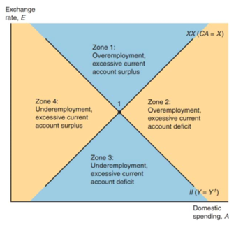
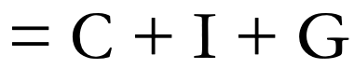
External balance: XX is upward sloping, locus of point st CA constant (is in equilibrium). You are in 1 => Now higher A => imports increase CA negative => need to depreciate to increase exports and decrease imports
Internal balance: II is downward sloping, locus of point st output is constant at potential. You are in 1 => Now higher A => to keep Y fixed foreign demand must decrease = need appreciation

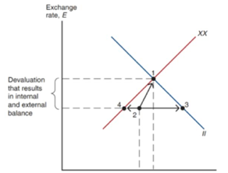
Possible policies
Expenditure swithching: change in exchange rate. Shifts world D from forign to domestic goods = move vertically
Expenditure changing: change domestic spending (total expenditure) C + I + G. Gov controls G (fiscal policy) = move horizontally
=> graph: in most cases you need both swhitching anch changing to fo to gain intenral and external equilibrium
I CAZZO DI PUNTINI SONO POSSIBILI SHIFT. SCRIVITI LE EQUAZIONI:
CA (Y, RER), D = C + I + G + CA

Possible Solution
Increase in the official price of gold in terms of the dollar and all other currencies (Why? Because then you would need more dollars to buy one ounce of gold). But
1. Inflationaty
2. CBs would expect further declines in the gold value of their dollar reserve => worsening the confidence problem.

USA was in a different position: had to hold the dollar price of gold at $35 an ounce + must guarantee that foreign central banks could convert their dollar holdings into gold at that price. => must hold sufficient gold reserves.
In practice, however, foreign central banks were willing to hold on to the dollars they accumulated, since:
i. these paid interest and were international money par excellence.
ii. World gold supplies were not growing enough to keep up = reserves in dollars
iii. Endogenous to the system, ex. Germany: booming economy in the 50s and 60s => appreciation pressure of the German mark against the dollar => Ger CB was permanently forced to buy dollars.

=> as long as most cb were willing to add dollars to their reserves and forgo the right of redeeming those dollars, the U.S. external constraint appeared looser, but at some point holdings of dollars by foreign CBs would exceed the U.S. gold stock. Dollars were no longer “as good as gold,” => risk of “run on the Fed”.

x

If us makes inflation others have to follow! = imported inflation
Higher gov spending: Medicare + Vietnam War => Ms up => P up
1970s, inflation arrived in europe. This was no accident: we know that when the reserve currency country speeds up its monetary growth => foreign cb purchase the reserve currency to maintain their E => Ms increases. Under trilemma no other option

0. Foreign ifnaltion, P* up

1. RER depreciation: you have extra demand for your goods, you are now with over employment and CA surplus!
2.
2a: to restabliush the internal equilibrium, given E: you need to spend less, Y = C + I + G + CA, to have the same Y with CA+ we need A- (C+ I + G)
2b: to restabliush the external equilibrium, given E: you need to import more, CA = EX(RER) – IM (RER, Y) = if RER up Y must increase.
3. Both II 1 and XX1 would shift downward (Appendix) by the same distance (approximately equal to E * δP)
Conclusion: if E could change: a rise in P*(inflation) would be matched by a proportional decrease in E (appreciation) = The way to avoid the imported inflation is to revalue the currency (that is, lower E).

4. If E is fixed, you are stuck in 1 with extra CA and extra employment => P increases => this pressure gradually shifts the two schedules back to their original position. As p up:
- demand fro your goods falls progressively
- Ms shrinks => Md > Ms => pressure for i up, E down <= Cb has to fight this: sells its currency and buys foreign currency = Ms up

The schedules stop shifting once P has risen in proportion to P*. At this stage the RER, employment, and the current account are at their initial levels, and point 1 is once again a position of internal and external balance.

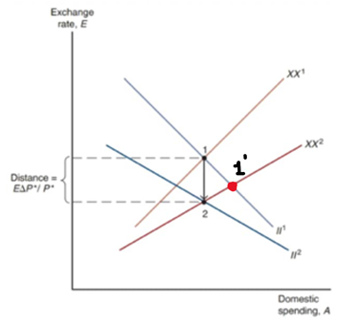

The U.S. economy entered a recession in 1970. To restore full employment and a balanced CA, the United States had to bring about a real depreciation of the dollar.
Two ways:
1. a fall in the U.S. price level, coupled with a rise in foreign price levels in response to continuing purchases of dollars by foreign central banks. => unemployment in the United States and inflation abroad was too painful <= big recession and unemployed required
2. devaluation of the dollar (not possible bc reserve currency country)=> as markets anticipated that this second option would be followed, massive sales of dollars in the foreign exchange market.
In March 1973 move to floating exchange rate system. At the time it was viewed as temporary.

Another problem: key expenditure-switching tool needed for internal and external balance—discrete exchange rate adjustment—inspired speculative attacks that made both internal and external balance progressively more difficult to achieve.

Appendix
Whenever you have to find a shift in a curve you have to hold constant one of the two variables on the two axis and see what must happen to the other variable in order to restore the initial eq (both internal and external). initial RER depreciation!
b. 1 is now point of excess Ca suurplus
- To re-establish external equilibrium given E (we are not saying internal is reestablished!), must increase imports by increasing domestic spending (rationale: we need higher imports): the XX curve shifts out. If it intersects on the right we need a right shift.
-To re-establish external eq given Y you need to aapreciate!

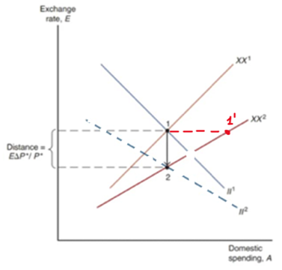

a. 1 is now point of excess employment.
- To re-establish internal equilibrium given the exchange rate (we are not saying external is reestablished!!!!!!), must decrease domestic spending (foreign demand has increased): the II curve shifts in. If it intersects on the left we need a left shift

